**Báo cáo Lab 3 OOP**

Họ và tên: Lê Nguyên Khải

MSSV: 20225727

**2.Working with method overloading**

Đoạn code bổ sung:

**public** **void** addDigitalVideoDisc(DigitalVideoDisc [] dvdList) {

**if** (dvdList == **null** || dvdList.length == 0) {

System.***out***.println("No disc has been added because the list is null or empty!");

**return**;

}

**int** n = dvdList.length;

**int** d = 0;

**for** (**int** i = 0; i < n; i++) {

**if** (dvdList[i] != **null** && qtyOrdered < ***MAX_NUMBERS_ORDERED***) {

items0rdered[qtyOrdered] = dvdList[i];

qtyOrdered += 1;

d += 1;

}

}

**if** (d == 0) {

System.***out***.println("No disc has been added!");

} **else** {

System.***out***.println(d + (d == 1 ? " disc has been added!" : " discs have been added!"));

}

}

// public void addDigitalVideoDisc(DigitalVideoDisc... dvdList) {

// if (dvdList == null || dvdList.length == 0) {

// System.out.println("No disc has been added because the list is null or empty!");

// return;

// }

// int n = dvdList.length;

// int d = 0;

// for (int i = 0; i < n; i++) {

// if (dvdList[i] != null && qtyOrdered < MAX_NUMBERS_ORDERED) {

// items0rdered[qtyOrdered] = dvdList[i];

// qtyOrdered += 1;

// d += 1;

// }

// }

// if (d == 0) {

// System.out.println("No disc has been added!");

// } else {

// System.out.println(d + (d == 1 ? " disc has been added!" : " discs have been added!"));

// }

// }

**public** **void** addDigitalVideoDisc(DigitalVideoDisc dvd1,DigitalVideoDisc dvd2){

addDigitalVideoDisc(dvd1);

addDigitalVideoDisc(dvd2);

}

}

Kết quả:

Đoạn code sửa ở Aims:

DigitalVideoDisc[] dvdList = {dvd1, dvd2, dvd3};

an0rder.addDigitalVideoDisc(dvdList);

an0rder.listDisc();



Sử dụng varargs tiện hơn nhưng theo thói quen thì em vẫn thích dùng [] hơn.

**3.Passing Parameter**

Code:

**package** Package;

**public** **class** TestPassingParameter {

**public** **static** **void** main(String[] args) {

DigitalVideoDisc jungleDVD = **new** DigitalVideoDisc("Jungle");

DigitalVideoDisc cinderellaDVD = **new** DigitalVideoDisc("Cinderella");

System.***out***.println("jungle dvd title: " + jungleDVD.getTitle());

System.***out***.println("cinderella dvd title: " + cinderellaDVD.getTitle());

*swap*(jungleDVD, cinderellaDVD);

System.***out***.println("jungle dvd title: " + jungleDVD.getTitle());

System.***out***.println("cinderella dvd title: " + cinderellaDVD.getTitle());

*changeTitle*(jungleDVD, cinderellaDVD.getTitle());

System.***out***.println("jungle dvd title: " + jungleDVD.getTitle());

}

// public static void swap(Object o1, Object o2) {

// Object tmp = o1;

// o1 = o2;

// o2 = tmp;

// }

**public** **static** **void** swap(DigitalVideoDisc dvd1, DigitalVideoDisc dvd2) {

String tmpTitle = dvd1.getTitle();

dvd1.setTitle(dvd2.getTitle());

dvd2.setTitle(tmpTitle);

String tmpCategory = dvd1.getcategory();

dvd1.setcategory(dvd2.getcategory());

dvd2.setcategory(tmpCategory);

String tmpDirector = dvd1.getDirector();

dvd1.setDirector(dvd2.getDirector());

dvd2.setDirector(tmpDirector);

**int** tmpLength = dvd1.getLength();

dvd1.setLength(dvd2.getLength());

dvd2.setLength(tmpLength);

**float** tmpCost = dvd1.getCost();

dvd1.setCost(dvd2.getCost());

dvd2.setCost(tmpCost);

}

**public** **static** **void** changeTitle(DigitalVideoDisc dvd, String title) {

String oldTitle = dvd.getTitle();

dvd.setTitle(title);

dvd = **new** DigitalVideoDisc(oldTitle);

}

}

Trả lời câu hỏi:  
• **swap()**: Không làm thay đổi nội dung hai đối tượng vì chỉ thao tác trên tham chiếu cục bộ.

• **changeTitle()**: Thay đổi nội dung của jungleDVD vì nó thao tác trực tiếp lên đối tượng mà tham chiếu gốc trỏ tới.

Đã thay đổi swap như trong code để hoạt động đúng.

Kết quả:

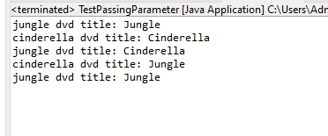

**5. Classifier Member and Instance Member**

Bổ sung và thay đổi code theo yêu cầu:

**private** **static** **int** *nbDigitalVideoDiscs* = 0;

**private** **int** id;

**public** DigitalVideoDisc(String title) {

**super**();

**this**.title = title;

*nbDigitalVideoDiscs*++;

**this**.id = *nbDigitalVideoDiscs*;

}

**public** DigitalVideoDisc(String title, String category, **float** cost) {

**super**();

**this**.title = title;

**this**.category = category;

**this**.cost = cost;

*nbDigitalVideoDiscs*++;

**this**.id = *nbDigitalVideoDiscs*;

}

**public** DigitalVideoDisc(String title, String category, String director, **float** cost) {

**super**();

**this**.title = title;

**this**.category = category;

**this**.director = director;

**this**.cost = cost;

*nbDigitalVideoDiscs*++;

**this**.id = *nbDigitalVideoDiscs*;

}

**public** DigitalVideoDisc(String title, String category, String director, **int** length, **float** cost) {

**super**();

**this**.title = title;

**this**.category = category;

**this**.director = director;

**this**.length = length;

**this**.cost = cost;

*nbDigitalVideoDiscs*++;

**this**.id = *nbDigitalVideoDiscs*;

}

**public** **int** getId() {

**return** id;

}

Kết quả khi chạy đã có ID:  


**6. Open the Cart class**

Phương thức mới ở Cart class:

**public** **void** findID(**int** id) {

**for** (**int** i = 0; i < qtyOrdered; i++) {

**if** (items0rdered[i].getId() == id) {

System.***out***.println(items0rdered[i].toString());

**return**;

}

}

System.***out***.println(String.*format*("Disc with id %d does not exist!", id));

}

**public** **void** findTitle(String title) {

**boolean** found = **false**;

**for** (**int** i = 0; i < qtyOrdered; i++) {

**if** (items0rdered[i].isMatch(title)) {

System.***out***.println(items0rdered[i].toString());

found = **true**;

}

}

**if** (!found) {

System.***out***.println("No match found for the title: " + title);

}

}

Phương thức mới trong DigitalVideoDisc class:

**public** **boolean** isMatch(String title) {

**if** (**this**.title == **null** || title == **null**) {

**return** **false**;

}

**return** **this**.title.toLowerCase().contains(title.toLowerCase());

}

**public** String toString(){

**return** String.*format*("ID: %d, title: %s, category: %s, director: %s, length: %d, cost: %.2f.",

**this**.id, **this**.title, **this**.category, **this**.director, **this**.length, **this**.cost);

}

CartTest class:

**public** **class** CartTest {

**public** **static** **void** main(String[] args) {

Cart cart = **new** Cart();

DigitalVideoDisc dvd1 = **new** DigitalVideoDisc("The Lion King",

"Animation", "Roger Allers", 87, 19.95f);

cart.addDigitalVideoDisc(dvd1);

DigitalVideoDisc dvd2 = **new** DigitalVideoDisc("Star Wars",

"Science Fiction", "George Lucas", 87, 24.95f);

cart.addDigitalVideoDisc(dvd2);

DigitalVideoDisc dvd3 = **new** DigitalVideoDisc("Aladin",

"Animation", 18.99f);

cart.addDigitalVideoDisc(dvd3);

cart.listDisc();

cart.findID(1);

cart.findID(4);

cart.findTitle("Star Wars");

cart.findTitle("Arcane");

}

}

Kết quả:

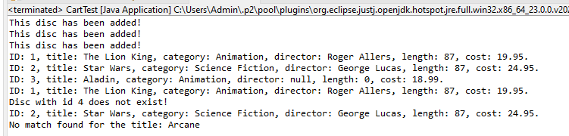

**7. Implement the Store class**

Store class:

**package** Package;

**public** **class** Store {

**public** **static** **final** **int** ***MAX_NUMBERS_INSTORE*** = 100;

**private** DigitalVideoDisc[] itemsInStore = **new** DigitalVideoDisc[***MAX_NUMBERS_INSTORE***];

**private** **int** qtyInStore = 0;

**public** **void** addDigitalVideoDisc(DigitalVideoDisc disc) {

**if** (qtyInStore < ***MAX_NUMBERS_INSTORE***) {

itemsInStore[qtyInStore] = disc;

qtyInStore += 1;

System.***out***.println("This disc has been added!");

} **else** {

System.***out***.println("This store is almost full!");

}

}

**public** **void** removeDigitalVideoDisc(DigitalVideoDisc disc) {

**boolean** found = **false**;

**for** (**int** i = 0; i < qtyInStore; i++) {

**if** (itemsInStore[i] != **null** && itemsInStore[i].equals(disc)) {

found = **true**;

**for** (**int** j = i; j < qtyInStore - 1; j++) {

itemsInStore[j] = itemsInStore[j + 1];

}

itemsInStore[qtyInStore - 1] = **null**;

qtyInStore -= 1;

System.***out***.println("This disc has been removed!");

**break**;

}

}

**if** (!found) {

System.***out***.println("This disc hasn't ever existed in store!");

}

}

**public** **void** printStore() {

System.***out***.println("Current DVDs in the store:");

**for** (**int** i = 0; i < qtyInStore; i++) {

System.***out***.println((i + 1) + ". " + itemsInStore[i].toString());

}

**if** (qtyInStore == 0) {

System.***out***.println("The store is empty.");

}

}

}

StoreTest class:

**package** Package;

**public** **class** StoreTest {

**public** **static** **void** main(String[] args) {

Store store = **new** Store();

DigitalVideoDisc dvd1 = **new** DigitalVideoDisc("The Lion King",

"Animation", "Roger Allers", 87, 19.95f);

DigitalVideoDisc dvd2 = **new** DigitalVideoDisc("Star Wars",

"Science Fiction", "George Lucas", 87, 24.95f);

DigitalVideoDisc dvd3 = **new** DigitalVideoDisc("Aladin",

"Animation", 18.99f);

DigitalVideoDisc dvd4 = **new** DigitalVideoDisc("Frozen",

"Animation", 10.99f);

store.addDigitalVideoDisc(dvd1);

store.addDigitalVideoDisc(dvd2);

store.addDigitalVideoDisc(dvd3);

store.printStore();

store.removeDigitalVideoDisc(dvd1);

store.printStore();

store.removeDigitalVideoDisc(dvd4);

}

}

Kết quả:

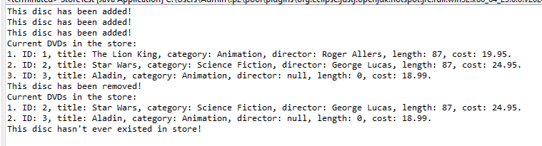

**8.Re-orgnaize your project**

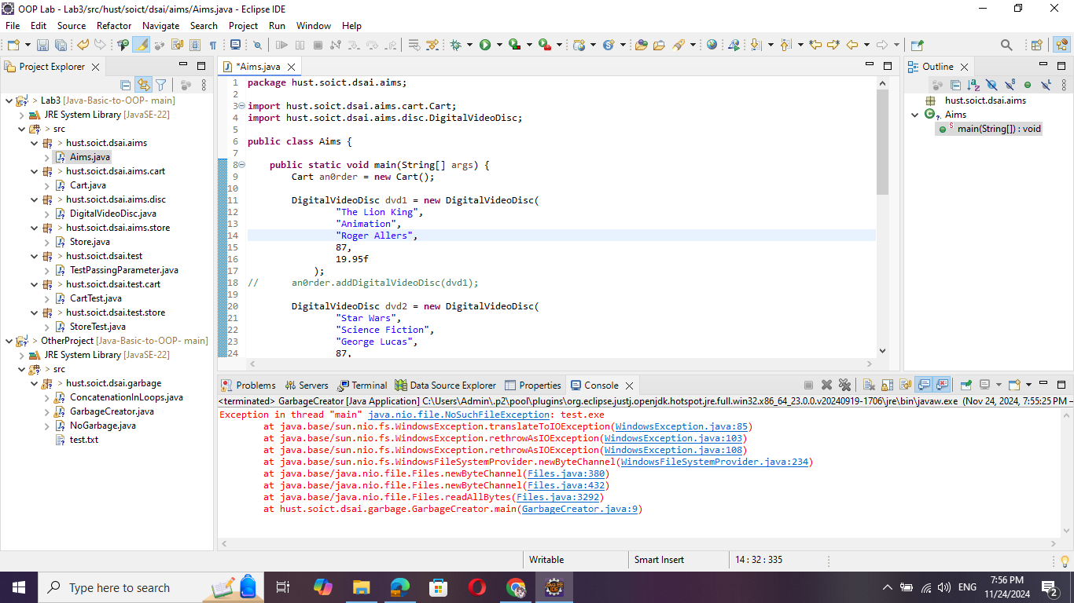

**9. String, StringBuilder and StringBuffer**

ConcatenationInLoops class code và kết quá:  
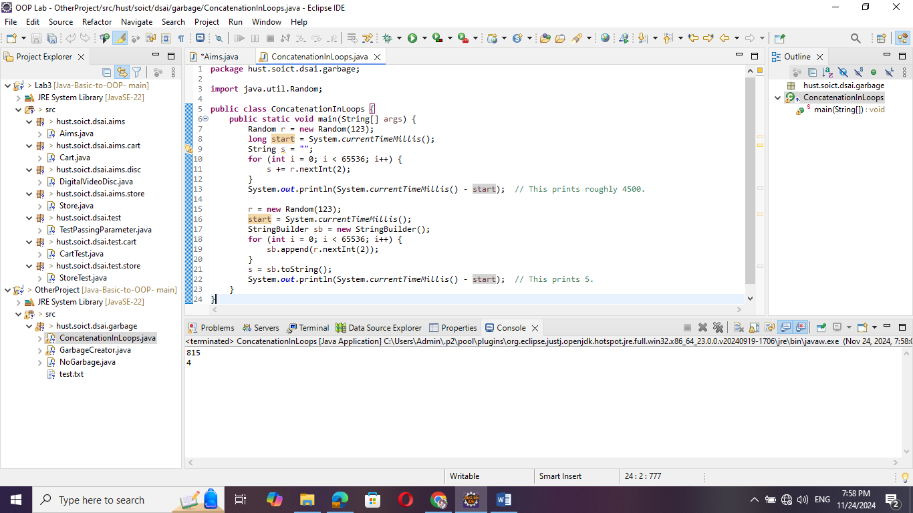

GarbageCreator class:  
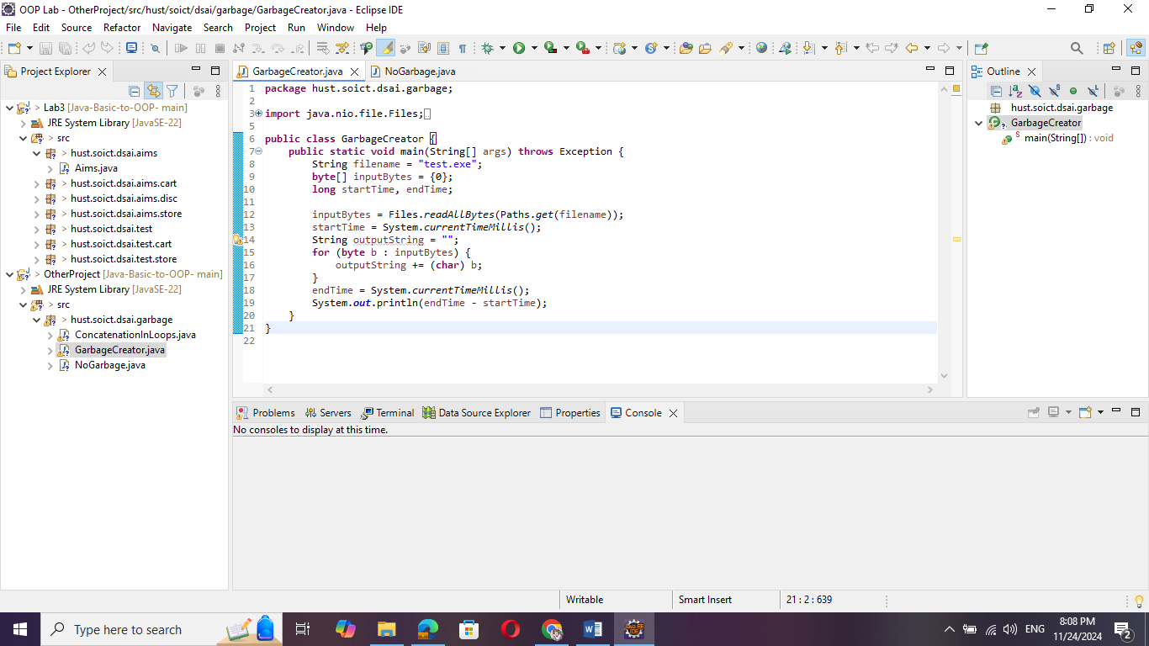

NoGarbage class:

